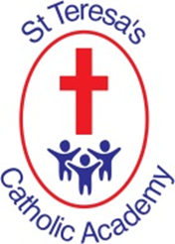
St Teresa’s Data against National Average 2023

 | % of children achieving expected standard
 | St Teresa’s | National
EYFS Good Level of Development | 73% | 67%
Phonics Test Year 1 | 95% | 79%
Y2 Reading EXP+ | 84% | 68%
Y2 Writing Exp+ | 75% | 59%
Y2 Maths EXP+ | 77% | 73%
Y2 Reading, Writing Maths | 68% | 54%
Y6 Reading EXP+ | 85% | 73%
Y6 Writing EXP+ | 85% | 71%
Y6 Maths EXP+ | 89% | 73%
Y6 Reading, Writing, Maths | 82% | 59%

